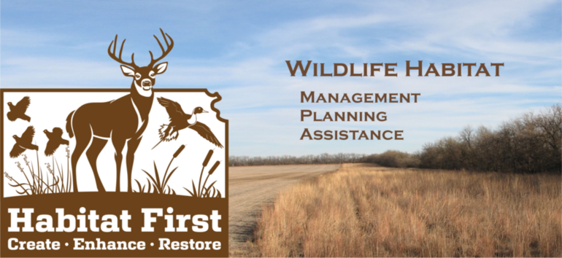
Habitat First is a program developed by the Kansas Department of Wildlife & Parks (KDWP) Wildlife Division for private landowners interested in developing or enhancing wildlife habitat on their property. To have positive impacts on the wildlife of Kansas we need to work with private landowners since about 98% of Kansas is privately owned. Under the program, wildlife biologists will deliver the following services to interested landowners:
-Technical assistance: planning, land management support, and habitat development tools
-Financial assistance: cost-share and/or sign-on incentives for habitat improvements
-Equipment loans: native grass drills, tree planters, fabric machines, prescribed burn equipment,
and root plows

-USDA programs: assistance with Environmental Quality Incentive Program applications
benefiting wildlife, Conservation Reserve Program enrollment, and management

Standardized practices and cost share rates make the program easy to explain and understand. Habitat management plans can be tailored to the property and to landowner preferences. Contact Andy Friesen 913-422-1314 ext. 20 andy.freisen@ks.gov or Tim Urban 913-422-1314 ext. 15 tim.urban@ks.gov to learn more.

